***ABSTRACT***

|  |
| --- |
| *In IT culture, mental health issues are all too frequently ignored. However, it's imperative to treat employee mental health issues before they have a negative impact on your business. According to the 2021 OSMI Mental Health in Tech Survey, more than 90% of employees in the technology industry report having a mental health issue. Nearly 64.7% of those surveyed claimed that a mental health problem had a negative impact on their productivity.*  *The research investigates that the when care options for mental health increases, implies that the treatment of mental health illness will also positive. Inter alia, when mental health as part of an employee wellness program increases, then the treatment of mental health will decrease. However, the there is limitation in this study which is related to wellness program that is single wellness program for different types of mental health illness is not efficiently work for every employee.*  *On the other hand, we run a logistic regression and the accuracy of the model is approximately 81% and we prefer to use the Nagelkerke’s R2 which suggests that the model explains roughly 54% of the variation in the outcome. This means that data fit the regression model.* |

**MENTAL HEALTH IN THE TECH INDUSTRY**

**INTRODUCTION**

Globalization of the economy and pro-business policies have given the information technology (IT) sector a huge boost. IT and IT-related professions are constantly under pressure to provide services effectively and affordably. Due to the ongoing physical and mental stress of their jobs, employees in the IT business are more likely to have a wide range of health issues. Mental health either causes, keeps, or makes diseases worse. Tension headache, hypertension, irritable bowel syndrome, etc., are among the common health issues triggered by mental health. It is brought on by the quick obsolescence of skills, job insecurity, uncertainty about future working circumstances, and the emergence of new workplace relationships as a result of globalisation and privatisation. The industry with the quickest growth is the IT sector. IT marketplaces globally have experienced the fastest growth in recent years because of strong demand. Because of their comparably greater levels of mental health issues than other employees, employers prefer to hire IT and ITES professionals. Every profession has goals, and an employee experiences mental issues when assigned goals that are impossible to meet or when they are unable to handle a certain scenario.

Since the start of the pandemic, mental health in the workplace has been a top concern for everyone. Research indicates that IT professionals are among the most likely to suffer. While working from home, being separated from friends and family, and worrying about getting sick have undoubtedly affected nearly everyone in the world, research suggests that these issues are more common among these individuals.

According to the Investing of Coping after Covid report from Westfield Health, 34% of IT workers have work-related anxiety, and 20% of them have trouble adjusting to the new ways of working. In addition, the study indicated that 44% of IT professionals reported that the pandemic had a negative impact on their mental health.

Over 1,000 software professionals were surveyed for a different AppDynamics study regarding how the pandemic affected their careers. In 2020, 81% of respondents said their jobs got more complicated, 89% said they felt under more pressure than ever, and 84% said it was hard to "switch off" at the end of the day.

Businesses that employ people who have mental health problems also suffer as a result. It is now impossible to overlook the relationship between productivity and mental wellness. Workers with chronic depression are 35% less efficient compared to those who have no psychological disorder or are undergoing therapy for it, according to the American Psychiatric Association. As a result, absentee, decreased productivity, and healthcare insurance cost the US economy $210.5 billion annually.

Therefore, if digital companies would like to stay productive, keep their best employees, and establish themselves as leaders in the field, they must prioritise employee mental wellness. With the best workers - and managers - the profession has to offer; the tech sector may become more powerful and resilient as a result.

According to research, the majority of tech workers:

* They are afraid of repercussions and won't discuss their mental health difficulties with their bosses.
* are concerned that their career may suffer if they are known to have a mental health issue.
* are unaware that their workplaces provide mental health assistance.

It is the management of the tech sector who must first and foremost address the problem of employee mental health. Managers must normalise discussions about mental health difficulties, make clear what supports are offered, and provide flexible work schedules for their devoted staff.

Thus, in this study, based on the data set our research question(s) is

1. How does the frequency of mental health illness and attitudes towards mental health vary by geographic location?
2. What are the strongest predictors of mental health illness or certain attitudes towards mental health in the workplace?

The statement of the first hypothesis is that the null hypothesis (H0) is that the difference between the treatment of mental health illness and state equals to zero, alternative hypothesis (H1), on the other hand, when there is no difference between the treatment of mental health illness is not equals to zero.

Mathematically, setting up the hypothesis as follows:

Null Hypothesis (H0): Treatment - State = 0

Alternative Hypothesis (H0): Treatment ≠ State

The statement for the second research question is that the strongest predictors of mental health illness the workplace. In this research question, we have to build a model and find out the best predictors (or explanatory variables) of the model. In this scenario, we perform a logistic regression on the given dataset (see in discussion section). It is a supervisor technique that means a model is created to produce accurate predictions for the response to fresh input data using a known collection of input data (the learning set) and known responses to the data (the output). If you have historical data for the outcome you are attempting to forecast, use supervised learning.

Why do we use logistic regression? The reason behind using this algorithm is based on a given dataset of independent variables, logistic regression calculates the likelihood that an event will occur, such as treatment or not treatment of mental health illness. Given that the result is a probability, the dependent variable (i.e., y_treatment in our study) range is 0 to 1. In logistic regression, the odds, that is, the probability of success divided by the probability of failure are transformed using the logit formula. The log odds are another name for this.

The data set consists of 1259 people from 48 different nations. People from the United States (60.0%), the United Kingdom (14.7%), and Canada (5.7%) made up the bulk of the population (80.1%). The remaining people (19.9%) come from a variety of continents, but mostly from Europe.

The data set had more than 25 variables, but we simplified it to 9 crucial attributes for analysis since we think they are most closely related to the question we were trying to answer. Additionally, p-values from the Chi-squared test were assessed to look for any correlations between these 10 key traits and the desired result.

This report will be highlighting mental health illness in the IT workplace or industry. Inter alia, it provides an overview of the research questions and provides as much information about the nature of differences or relationships like report differences among groups or not, the level of statistical significance of the difference p-level, etc.

**Analysis**

In this subsection, we are going to investigate the hypothesis or research questions using the SPSS tool. In this given data set of mental health in tech survey, there are 27 variables and data type of most of the variables are categorical in nature. So, first we need to refine (or recode) the data set, and then begin implementation of the hypothesis.

In the case of the first hypothesis, there are two categorical variables i.e., Treatment and State. So, we need to convert both of these variables into numeric.

Recoding treatment:

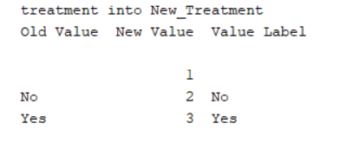

And, Recoding state:

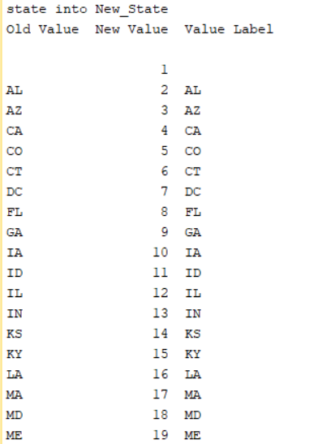

In this test, we need to use Chi-square test because this test is used to determine if two categorical variables are independent.

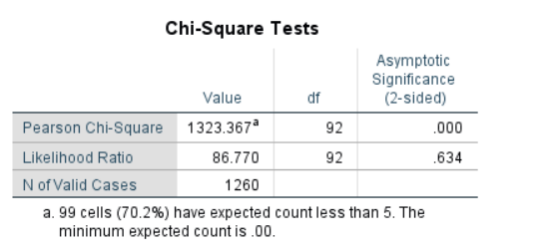

The p-value of the test is less than the level of significance implies that 0.000 < 0.05. Based on the evidence, it can be concluded that there is a statistically significant difference from the hypothesized values that we supplied. So, the null hypothesis can be rejected and support an alternative hypothesis. Therefore, mental health illness and attitudes towards mental health vary by geographic location.

Based on the data set, we state more appropriate hypothesis. Below, we state few different hypotheses.

In this case of hypothesis, we interested in one variable that is Benefits.

Null Hypothesis (H0): Benefits = 0

Alternative Hypothesis (H1): Benefits ≠ 0.

Recoding the Benefits in to New_Benefits as

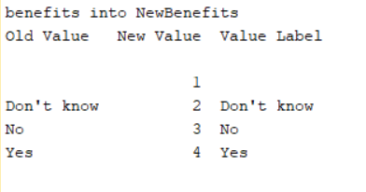

In this test, we need to use One sample proportion test because it is used to estimate the proportion of population.

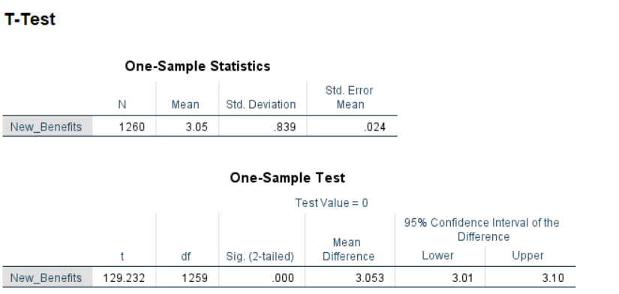

The p-value of the above test is close to zero and less than the level of significance i.e., 0.000 < 0.05. This means that the variable is statistically significant from the hypothesized values that we supplied. So, the null hypothesis can be rejected and support an alternative hypothesis. Therefore, it can be concluded that employers provide mental health benefits.

In case of this hypothesis, there is one variable that is seek_help .

Null Hypothesis (H0): seek_help = 0

Alternative Hypothesis (H1): seek_help ≠ 0.

Recoding the variable seek_help into New_seek_help as

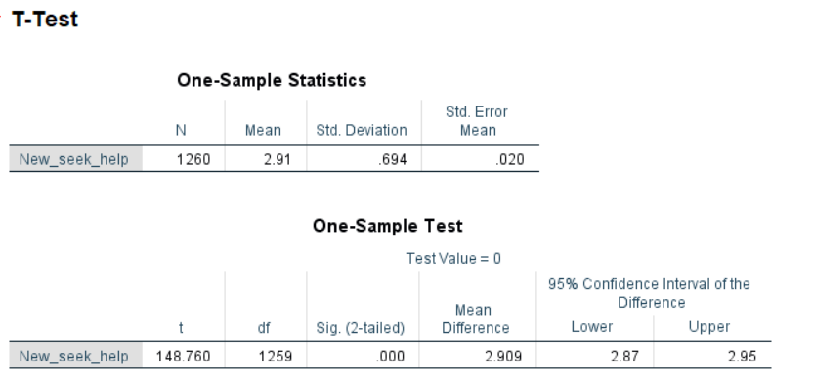

The p-value of the above test is close to zero and less than the level of significance i.e., 0.000 < 0.05. This means that the variable is statistically significant from the hypothesized values that we supplied. So, the null hypothesis can be rejected and support an alternative hypothesis. Therefore, it can be concluded that your employer provides resources to learn more about mental health issues.

In the hypothesis, we are interested in two categorical variables i.e., Country and Benefits. So, we need to convert both of these variables into numeric or if we don’t do this, then SPSS is smart enough and provides results with converting.

Null Hypothesis (H0): Country - Benefits = 0

Alternative Hypothesis (H1): Country ≠ Benefits

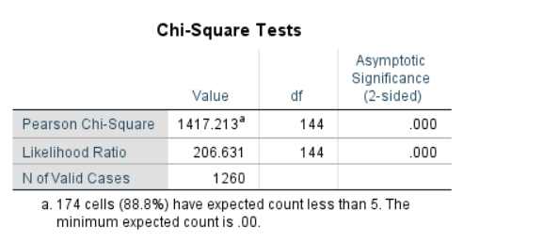

The p-value of the test is less than the level of significance implies that 0.000 < 0.05. Based on the evidence, it can be concluded that there is a statistically significant difference from the hypothesized values that we supplied. So, the null hypothesis can be rejected and support an alternative hypothesis. Therefore, the country helps and provides resources to learn more about mental health issues.

Result

This section reports how we have analysed the dataset and also reports the findings of our research questions/hypotheses earlier in the introduction.

The statement of the first hypothesis is that mental health illness varies by geographic location. In the hypothesis, there are two categorical variables that are Treatment and State. Thus, the p-value of the test is less than the level of significance implies that 0.000 < 0.05. Based on the evidence, it can be concluded that there is a statistically significant difference from the hypothesized values that we supplied. So, the null hypothesis can be rejected and support an alternative hypothesis. Therefore, mental health illness and attitudes towards mental health vary by geographic location.

On the other hand, the second statement of research question indicate that we need to investigate the strongest predictors of mental health illness or certain attitudes towards mental health in the workplace. Therefore, we require to investigate the strongest predictors. After performing logistic regression, we get the below result as

* For New_Benefits variable: the p-value of the variable is close to zero and the level of significance is 0.05. Since, 0.000 < 0.05, it is sufficient evidence that the new benefits of mental health illness is statistically significant.
* For New_work_interfere variable: the p-value of the variable is close to zero and the level of significance is at 0.05, implies that the p-value is less than the 0.05, which indicates that the new work interfere is statistically significant.
* For New_Family_History variable: the p-value of the variable is close to zero which is less than the level of significance i.e., 0.05, this means that the new family history is statistically significant.
* For New_care_options variable: the p-value of the variable is 0.002 and the level of significance is 0.05. Since, 0.002 is less than the level of significance 0.05, so it means that it is sufficient evidence that the new care options of mental health illness is statistically significant.
* For New_Well_Pro variable: the p-value of the variable is 0.768 and the level of significance is 0.05. Since, 0.768 is more than the level of significance 0.05, so it means that it is sufficient evidence that the new wellness program of mental health illness is not statistically significant.
* For New_Leave variable: the p-value of the variable is 0.758 and the level of significance is 0.05. Since, 0.758 is more than the level of significance 0.05, so it means that it is sufficient evidence that the medical leave in case of mental health illness is not statistically significant.
* For New_ Anonymity variable: the p-value of the variable is 0.055 and the level of significance is 0.05. Since, 0.055 is more than the level of significance 0.05, so it means that it is sufficient evidence that the anonymity protected in case of mental health is not statistically significant.
* For New_seek_help variable: the p-value of the variable is 0.120 and the level of significance is 0.05. Since, 0.120 is more than the level of significance 0.05, so it means that it is sufficient evidence that the resources to learn more about mental health issues is not statistically significant.
* For New_supervisor variable: the p-value of the variable is 0.945 and the level of significance is 0.05. Since, 0.945 is more than the level of significance 0.05, so it means that it is sufficient evidence that discussion your mental health issue direct to supervisor is not statistically significant.

Discussion

The purpose of this section is to evaluate and interpret the results, especially with respect to the research questions/hypotheses earlier in the introduction.

The statement of the first hypothesis is that mental health illness varies by geographic location. In the hypothesis, there are two categorical variables that are Treatment and State. So, we need to convert both of these variables into numeric. Thus, recoding all comes into the picture and then testing the null hypothesis.

In this test, we need to use Chi-square test because this test is used to determine if two categorical variables are independent.



The p-value of the test is less than the level of significance implies that 0.000 < 0.05. Based on the evidence, it can be concluded that there is a statistically significant difference from the hypothesized values that we supplied. So, the null hypothesis can be rejected and support an alternative hypothesis. Therefore, mental health illness and attitudes towards mental health vary by geographic location.

On the other hand, the second statement of research question indicate that we need to investigate the strongest predictors of mental health illness or certain attitudes towards mental health in the workplace.

Thus, we require to investigate the strongest predictors. Now, come to the logistic regression model and how we perform this regression model. As we already observe the dataset and the data type of more than 24 variables is categorical in nature. So, first we need to clean the data and after that perform the algorithm.

Recoding few relevant categorical variables to numeric as:

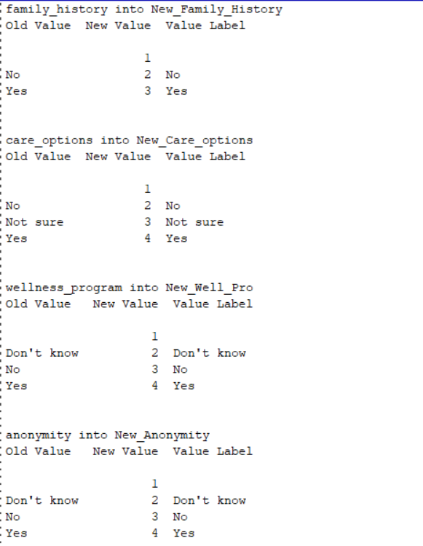

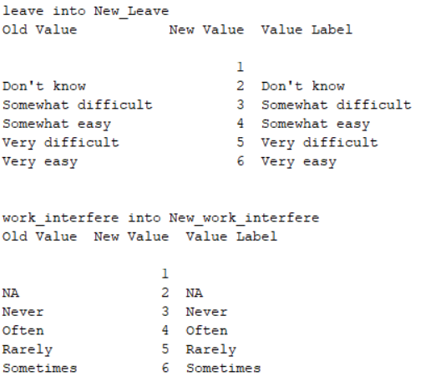

Now, we run the Binary (or Logistic) regression in SPSS.

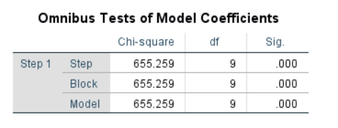

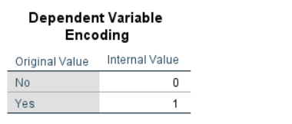

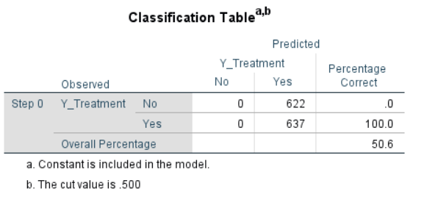

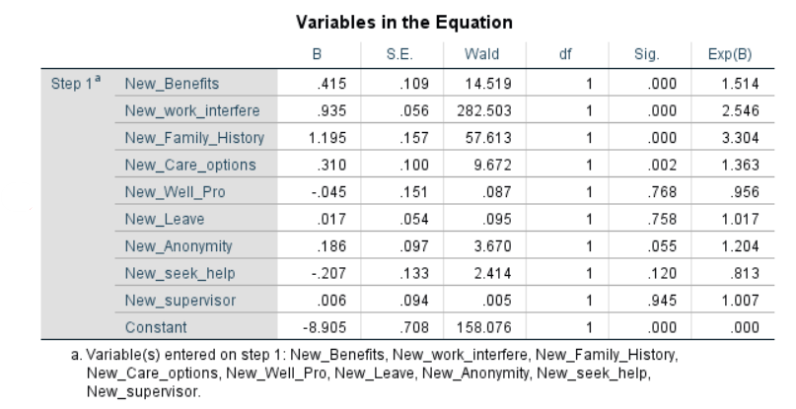

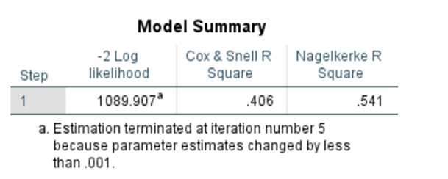

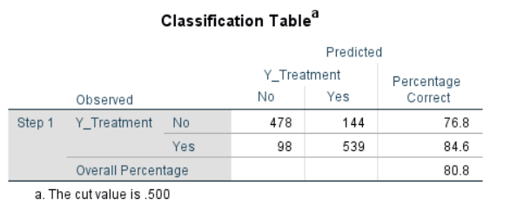

In this regression model, our dependent variable is y_treatment and on the other hand, independent variables are New_Benefits, New_work_interfere, New_Family_History, New_Care_options, New_Well_Pro, New_Leave, New_Anonymity, New_seek_help, and New_supervisor.

The dependent variable takes value 1, when there is treatment of mental health illness and takes value 0, when there is no treatment of mental health illness (see result dependent variable encoding).

*Regression Equation*:

Logit (y_treatment) = b0 + b1*New_Benefits + b2*New_work_interfere + b3*New_Family_History + b4*New_Care_options + b5*New_Well_Pro + b6*New_Leave + b7*New_Anonymity + b8*New_seek_help + b9*New_supervisor

Logit (y_treatment) = -8.905 + 0.415*New_Benefits + 0.935*New_work_interfere + 1.195*New_Family_History + 0.310*New_Care_options - 0.45*New_Well_Pro + 0.017*New_Leave + 0.186*New_Anonymity - 2.07*New_seek_help + 0.006*New_supervisor

**Interpretation**:

* The slope coefficient of b1 is 0.415 which implies when the new benefits of mental health increases, then the treatment of mental health illness is positive. On the other hand, we can say that the intercept has a positive sign, then the probability of having the mental health treatment will be more than 0.5.
* The slope coefficient of b2 is 0.935 which implies when the interference with your work increases, then the treatment of mental health illness is positive or increases. On the other hand, we can say that the intercept has a positive sign, then the probability of having the mental health treatment will be more than 0.5.
* The slope coefficient of b3 is 1.195 which implies when family history of mental illness increases, then the treatment of mental health illness is positive or increases. On the other hand, we can say that the intercept has a positive sign, then the probability of having the mental health treatment will be more than 0.5.
* The slope coefficient of b4 is 0.310 which implies when care options for mental health increases, then the treatment of mental health illness is positive or increases. On the other hand, we can say that the intercept has a positive sign, then the probability of having the mental health treatment will be more than 0.5.
* The slope coefficient of b5 is -0.45, which implies when mental health as part of an employee wellness program increases, then the treatment of mental health illness is negative or decreases. On the other hand, we can say that the intercept has a negative sign, then the probability of having the mental health treatment will be less than 0.5.
* The slope coefficient of b6 is 0.017 which implies when employee take a medical leave in case of a mental health condition increases, then the treatment of mental health illness is positive or increases. On the other hand, we can say that the intercept has a positive sign, then the probability of having the mental health treatment will be more than 0.5.
* The slope coefficient of b7 is 0.186 which implies employee anonymity protected if he/she choose to take advantage of mental health increases, then the treatment of mental health illness is positive or increases. On the other hand, we can say that the intercept has a positive sign, then the probability of having the mental health treatment will be more than 0.5.
* The slope coefficient of b8 is -0.207, which implies when employer increase resources to learn more about mental health issues, then the treatment of mental health illness is negative or decreases. On the other hand, we can say that the intercept has a negative sign, then the probability of having the mental health treatment will be less than 0.5.
* The slope coefficient of b9 is 0.006 which implies when employee willing increases to discuss a mental health issue direct to supervisor, then the treatment of mental health illness is positive or increases. On the other hand, we can say that the intercept has a positive sign, then the probability of having the mental health treatment will be more than 0.5.

The Omnibus Tests of Model Coefficients is used to check that the new model (with explanatory variables included) is an improvement over the baseline model. It uses chi-square tests to see if there is a significant difference between the Log-likelihoods (specifically the -2LLs) of the baseline model and the new model. If the new model has a significantly reduced -2LL compared to the baseline then it suggests that the new model is explaining more of the variance in the outcome and is an improvement. Here the chi-square is highly significant (chi-square = 655.259, df = 9, p<.000) so our new model is significantly better.



The Model Summary result provides the -2LL and pseudo-R2 values for the full model. The -2LL value for this model (1089.907) is what was compared to the -2LL for the previous null model in the ‘omnibus test of model coefficients’ which told us there was a significant decrease in the -2LL, i.e., that our new model (with explanatory variables) is significantly better fit than the null model. The R2 values tell us approximately how much variation in the outcome is explained by the model (like in linear regression analysis). We prefer to use the Nagelkerke’s R2 which suggests that the model explains roughly 54% of the variation in the outcome. This means that data fit the regression model.

Now, we are talking about the most important table that is Classification_Table. Thus, the overall percentage (or **model accuracy**) row tells us that this approach to prediction is **correct 81%** (approx.). Therefore, it is an appropriate and better model.

Limitation of the study and suggestions for future:

Employers can improve employees' health and assist specific employees in overcoming specific health-related issues by implementing employee wellness programmes. The employer may require employees to complete training, hold staff meetings, or even partner with a third party offering a range of wellness initiatives. Employees are one of a company's most precious assets, and guaranteeing their top mental health makes them more productive. The productivity and financial success of a firm are typically directly impacted by the health and wellness of its workforce. Many firms are aware of this and willing to invest in such initiatives.

However, there are certain disadvantages to wellness programmes. While these programmes can sometimes boost morale, mental health and productivity, they can also make workers who don't need or want to participate resentful of the programme. Additionally, businesses (IT companies) must frequently make significant financial expenditures in wellness programmes; as a result, if these investments are not utilised or valued by employees, firms may end up paying significantly more money than is necessary.

The lack of a consensus on what comprises wellbeing is a significant drawback. What one employer would view as a wellness programme may not be viewed in the same way by another employer. Another drawback is that an organization's objectives might not be the same as those of its personnel. The expense of putting up and sustaining these kinds of initiatives, including staff time and other resources required.

For future suggestion is that organization collect the data (such as feedback, ration or review) from the employee who engage in wellness program, and based on the feedback or review, organization will improve their wellness programs. Furthermore, in companies we can develop more than one wellness programmes based on the criticality of the business and work culture. This will an employee in improving their mental health by participating in such wellness programmes, for betterment an employee could be allow to attend more than one wellness program for more improvement.

# **References**

Meeting the mental health needs of employees: A personal approach. (n.d.). Workplace Mental Health Manual for Nurse Managers. <https://doi.org/10.1891/9780826137463.0012>

Mental-health implications of aging in industry. (2013). Industrial Organizations and Health, 429–440. <https://doi.org/10.4324/9781315013565-33>

Padma, V., Anand, N. N., Gurukul, S. M., Javid, S. M., Prasad, A., &amp; Arun, S. (2015). Health problems and stress in Information Technology and Business Process Outsourcing Employees. Journal of Pharmacy and Bioallied Sciences, 7(5), 9. <https://doi.org/10.4103/0975-7406.155764>

Research. Open Sourcing Mental Health - Changing how we talk about mental health in the tech community - Stronger Than Fear. (n.d.). Retrieved December 26, 2022, from <https://osmihelp.org/research>

Understanding workplace mental health. (n.d.). Workplace Mental Health Manual for Nurse Managers. <https://doi.org/10.1891/9780826137463.0002>